**BRAC UNIVERSITY**

**Department of Computer Science and Engineering**

**CSE420: Compiler Design**

**Quiz 02, Summer 2016**

**Duration: 40 minutes, Total Marks: 20**

|  |
| --- |
| Student Name:  Student ID:  Section: |

**1.** i) State the basic differences among Quadruples, Triples and Indirect Triples. **[3]**

ii) Translate the expression ***x=a[2][3]+1*** into quadruples, assume, the array is 4*4, base address is 100, and width is 32. **[3]**

2. Determine the target statements of following code segment using the techniques of back-patching: **[8]**

|  |
| --- |
| while (a<200 && a>50 ) {  if(a%2==0)  a=a-x;  else  a=a+x;  x++;  } |

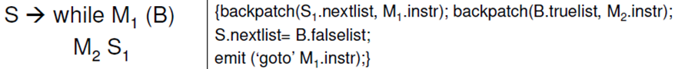

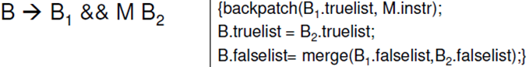

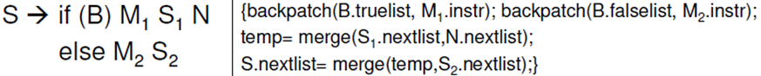

**3.** A syntax directed definition for declaring identifiers is:

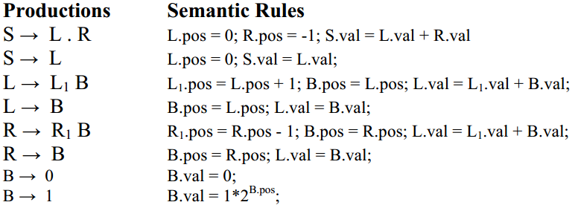

i) Draw an annotated parse tree for the sentence: 10.11

ii) Draw the dependency graph for the parse tree of (i). **[4 + 2]**